
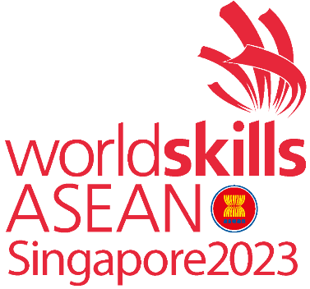

Test Project
Graphic Design Technology

Packaging Design
WSA2023_TP1_Packaging Design
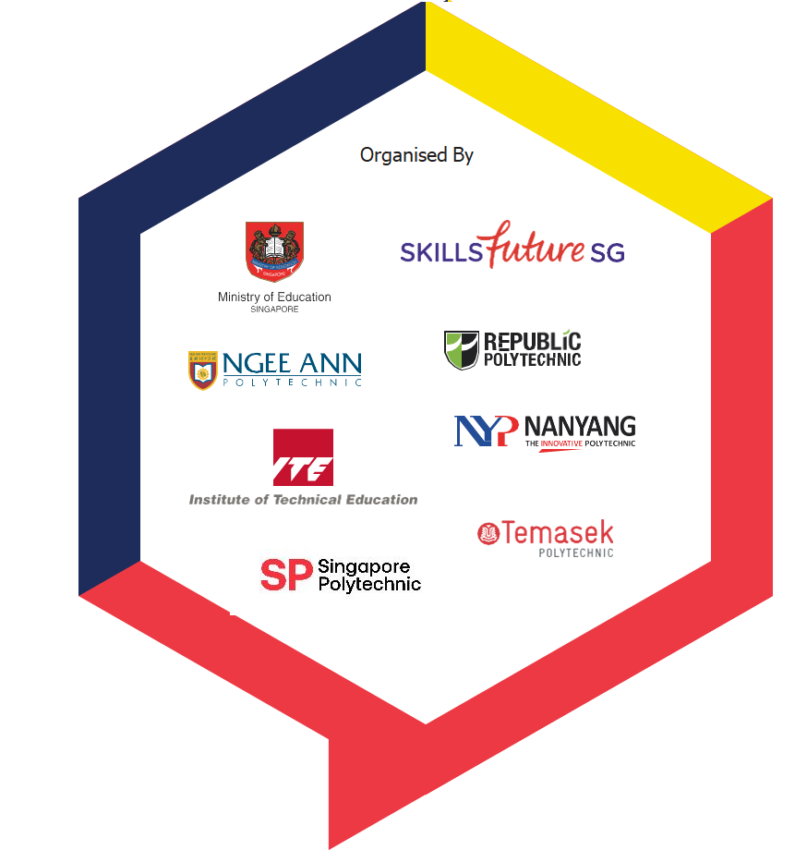
Time: 6 Hours
Submitted By: | Country
Prasit Kongngoolueam, | Thailand
Azizul Mohamad Sam | Malaysia
Lina Tay | Singapore



Contents
- Briefing of the project page 3
- Description of the project page 3
- Target audience page 4
- Task to perform page 4
- Description of the Task page 4
- Task 1 page 5
- Task 2 page 6 - 7
- Task 3 page 8 - 9
- Instructions to the Competitor page 10

Appendix
This Test Project contains the following documentation/files:
- WSA2023_TP40_M1_EN_TP.docx ( This document )
- WSA2023_TP40_M1_Recycle Logo and QR Code ( Appendix 1.4 Task 2 & 3 )
- WSA2023_TP40_M1_Image ( Appendix 1.4 Task 2 & 3 )
- WSA2023_TP40_M1_Text.docx ( Appendix 1.1 Task 1, 1.2 Task 2 and 1.3 Task 3 )

Briefing of the project

Introduction

Overview:

Project: Design Logo, Sauce Label Sticker for Sachets of Singapore Gift Package Design
Singaporeans are obsessed with food. We can expound ceaselessly on where to find the best bak chor mee (minced meat noodles) and will queue for hours for a good yong tau foo (surimi-stuffed tofu and vegetables). Perhaps because most of us are descendants of immigrants thrust into an artificial construct of a nation, or maybe because we live in a country that is constantly renewing and rebuilding, one of the few tangible things that connects us to the past and our cultural identity is food.
There are many facets of Singaporean cuisine: Malay, Chinese, Indian, Eurasian (a fusion of European and Asian dishes and ingredients) Peranakan (combining Chinese and Malay food traditions), and catch-all Western, which usually means old-school Hainanese-style British food—a local version of Western food adapted by chefs from the southern Chinese province of Hainan, who worked in British restaurants or households.
Singapore is a melting pot of cuisines, incorporating a rich heritage of food dishes consisting of Chinese, Indian, Malaysian and Indonesian influences and generations of food heritage and culinary creations pushed the envelope on Singaporean cuisine. “Taste of Singapore” has been created to celebrate Singapore flavours and the rich depth of our culinary past and future from celebrity chefs and michelin star’s hawker masters in the form of a souvenir or gift for tourists or local alike to bring back home for their family and friends.

Description of the project
Design:
1. Create your own brand logo “Taste of Singapore”
2. Choose and design Sauce Label Sticker for THREE (3) different Singaporean Dishes sachets
Each individual Sauce Label Sticker sachet must reflect the specialty dish sauce of the Singapore.
3. Design an environmentally sustainable gift package to hold THREE (3) of the sachets.
One gift package must contain all THREE (3) different flavours of Singapore.

You must design a logo for “Taste of Singapore” brand. The packaging should be inspired by the art, culture, colours and history of Singapore. It must be a combination of creative thinking and cultural elements with local folk culture, its religious and cultural backgrounds and other elements, and the use of creative or innovative design approach. In addition, it should be environmentally sustainable, space saving, reducing wastage of material usage.

Target audience

Demographics
Anyone who loves sauces especially tourists travelling to Singapore who want the special sauce of Singapore for a souvenir to bring back home for their family and friends.

Task to perform

Task1: LOGO DESIGN (2.5 Hour)
(Submit before lunch)

Task 2 & 3 ( 3.5 hrs )
Task 2: SAUCE LABEL STICKER (for Sachets)
( Submit after Lunch )
Task 3: GIFT PACKAGE DESIGN
( Submit after Lunch )

Task 1: LOGO DESIGN

(Submit before lunch)

Concept
Create: Create your own brand logo “Taste of Singapore”
- You can use any font that can reflect your brand effectively
- You can use only font or font with any graphic for the logo
- The logo should be vector graphic only
- You are to create TWO (2) versions for logo: CMYK and TWO (2) spot ( Pantone+ CMYK Coated )
- Use the text provided in ( Appendix 1.1 Task 1 )

Specifications
Colours TWO (2) versions:
- TWO (2) spot ( PANTONE+ CMYK Coated )
- CMYK
- ICC Profile: Coated GRACol 2006 (ISO 12647-2:2004)
- Trapping 0.4pt (If necessary)
- Paper: 170 gsm

Naming
Note: YY represents your competitor number

- Logo File Name: YY_LOGO_2PMS.ai
- Logo File Name: YY_LOGO_CMYK.ai
- Logo File Name: YY_LOGO_2PMS&CMYK.pdf

You must deliver
( Submit before lunch )

Digital
- 1 final file of the logo in TWO (2) spot ( PANTONE+ CMYK Coated ) colours in Ai format.
- 1 final file of the logo converted to CMYK in Ai format.
- 1 final composite PDF/X-4:2010 file of the logo CMYK & TWO (2) spot ( PANTONE+ CMYK Coated ).

Print
1 Printout of the logo of CMYK & TWO (2) spot ( PANTONE+ CMYK Coated ) in A4 size paper.
Remarks:
Folders as specified in “Instructions to the Competitor”
Only files from these folders will be assessed.
Task 2: SAUCE LABEL STICKER ( FOR SACHETS )

Concept

Create: Design Sauce Label Stickers for THREE (3) Singapore Dishes.
1. Chicken Rice
2. Chilli Crab
3. Fish Head Curry

All Texts and Elements from ( Appendix 1.2 Task 2 ) must be included in your design:
- QR Code : The QR code link to Cooking Method YouTube. You may use provided QR codes.
- The images must match the ingredient of each Singapore Sauce.
- You may use provided images from (“WSA2023_TP40_M1_Recycle Logo and QR Code folder”) and
(“WSA2023_TP40_M1_Image”) under folder ( Appendix 1.4 Task 2 & 3 Images ) or you may choose
to create your own illustrations.

Specifications
- Max Dimensions of die line : 90 x 130 mm ( front and back )
- Bleed for die line (if necessary) : 3mm ( tolerance of +/- 0.2 mm )
- Colours : CMYK + dieline plate (name: dieline) with overprint
- ICC Profile : Coated GRACol 2006 (ISO 12647-2:2004)
- Ink density : 300%
- Grayscale and Colour image
Resolution : 280 – 300 ppi 100%
- Bitmap image Resolution : 600 – 1200 ppi 100%
- Sticker Paper : 80 - 120 gsm

Note: Images must not be embedded in Illustrator

Naming
Note: YY represents your competitor number

- Logo File Name: YY_SauceLabelSticker.ai
- Logo File Name: YY_SauceLabelSticker.pdf

You must deliver

Digital
- 1 final composite PDF/X-4:2010 file of Each Sauce of your design (front and back) at 100% with dieline on one separate layer, bleed, colour bars, registration marks and trim marks only.

Print
- 1 printout of Each Sauce of your design (front and back) at 100% on A3 size paper. Each design (front and back) with bleed, dieline, colour bars, registration marks and trim marks only.
- 1 printout of Each Sauce of your design (front and back) at 100%, trimmed to size and mounted on the mounting board provided.
Mockup
- 1 final 3D mock-up of each sauce label stickers at 100% of the final size on THREE (3) flat sachets provided.
- 1 final 3D mock-up of each sauce label stickers at 100% of the final size on THREE (3) “filled” sachets provided.

Task 3: GIFT PACKAGE DESIGN

Concept

Create: Gift Package to contain THREE (3) Singapore Sauce Label Sachet
Design an environmentally sustainable gift package to contain THREE (3) Singapore Sauce Label Sachet for anyone who loves their unique sauces used for dishes especially tourists travelling to Singapore who want the special sauce of Singapore as a souvenir to bring back home for their family and friends. One package contains THREE (3) flavours of Singapore special sauces (Your design from Task 2). The package should be attractive and creatively design and both informative and marketable. Overall design must be inspired by the art, culture, colours and history of Singapore.

Specifications
These elements in (“WSA2023_TP40_M1_Image ) under ( Appendix 1.4 Task 2 & 3 Images ) and
(“WSA2023_TP40_M1_Text ) under ( Appendix 1.3 Task 3 ) must be included in your package design

- Images: Use a minimum of TWO (2) supplied images on your package design. You may combine and edit the images according to your design, however, they must remain raster.
- You must create at least 1 of your own illustration for the package design to represent
The THREE (3) sauces.
- Essential Package Symbol to be included in Vector-Format only: Recycle
from ( WSA2023_TP40_M1_Recycle Logo and QR Code folder ) under folder
( Appendix 1.4 Task 2 & 3 Images )
- The package MUST NOT have any glue area and should hold the product securely

- Max Dimensions of dieline : 297 mm x 420 mm (A3 flat)
- Dimensions of barcode : 25 mm width and must be 100% K
- Bleed for die line (if necessary) : 3 mm ( tolerance of +/- 0.2 mm )
- Clear window : You must have clear window to show the product
from outside the package
- Colours : CMYK colours & TWO (2) spot ( PANTONE+ CMYK Coated ).
- Separate layers : dieline & fold lines with overprint
+ dieline plate ( name: dieline )
- ICC Profile : Coated GRACol 2006 (ISO 12647-2:2004)
- Ink density : 300%
- Trapping (if necessary) : 0.4 pt

- Grayscale and Colour image Resolution : 280 – 300 ppi 100%
- Bitmap image Resolution : 600 – 1200 ppi 100%
- Paper : 250 gsm
Note: You MUST NOT embed images in Illustrator

Naming
Note: YY represents your competitor number

- Logo File Name: YY_GiftPackageDesign.ai
- Logo File Name: YY_GiftPackageDesign.pdf

You must deliver

Digital
- 1 final composite PDF/X-4:2010 file including dieline, fold lines on separate layers with bleed, colour bars, registration marks and trim marks only.

Print
- 1 printout of your design at 90% on A3 size with bleed, dieline, colour bars and registration marks and trim marks only.
- 1 printout trimmed at 90% and mounted on mounting board provided.

Mockup
- 1 final 3D mock-up of task THREE (3) ( Gift package ) ( without fold lines ) at 100% of the final size with the THREE (3) Singapore flavoured Sauces. ( from task 2 )

Remarks:
Folders as specified in “Instructions to the Competitor”
Only files from these folders will be assessed.

INSTRUCTIONS TO THE COMPETITOR

TIME LIMIT FOR THIS TEST PROJECT
The Test Project module 1 must be completed in 6 hours

- Create a folder on your Desktop called YY_MOD1 (where YY represents the number of your workstation).
- This folder must include the following subfolders “Task 1, Task 2 and Task 3”. The subfolders are to contain two folders:

A folder named “Original”: it should contain all the files used for the development of your project.
A folder named “Final”: it should contain all of the final files. (PDF, native, fonts and linked images)
You must include your workstation number on the presentation board and printouts for marking and delivery to your workstation (the number should be included outside of the artwork area)
Regarding image assessment for the tasks: the colour mode of your images will be evaluated in the PDF files. The final resolution and file formats will be assessed in your working software, such as Illustrator or Photoshop.
The JPG file format is NOT ACCEPTED for images; only the following file formats are acceptable .TIF / .EPS / .Ai / .PSD
Task 1 must be created in Illustrator; Task 2 the final must be in Illustrator; Task 3 final layout must be created in Illustrator.
Images must not be embedded or placed in Adobe Illustrator.

